Name: Vinit Kumar Sharma

Email: [vinitkumar261995@gmail.com](mailto:vinitkumar261995@gmail.com)

Subject: Cyber Security Essentials Batch-1, Day-4 Assignment

**Day-4 Assignment**

**Question 1:** Find out the mail servers of the following domain:

* Ibm.com
* Wipro.com

[WWW.IBM.COM](http://WWW.IBM.COM)

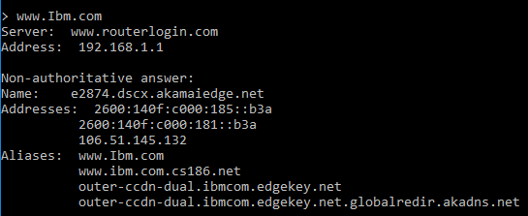

[WWW.WIPRO.COM](http://WWW.WIPRO.COM)

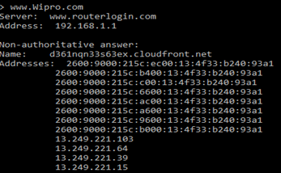

**Question 2:** Find the locations, where these email servers are hosted.

* Using mx command

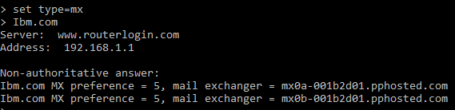

**Question 3:** Scan and find out port numbers open 203.163.246.23

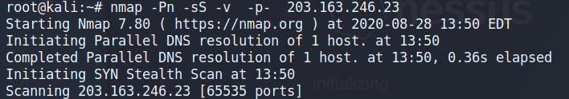

**Question 4:** Install Nessus in a VM and scan your laptop/desktop for CVE.

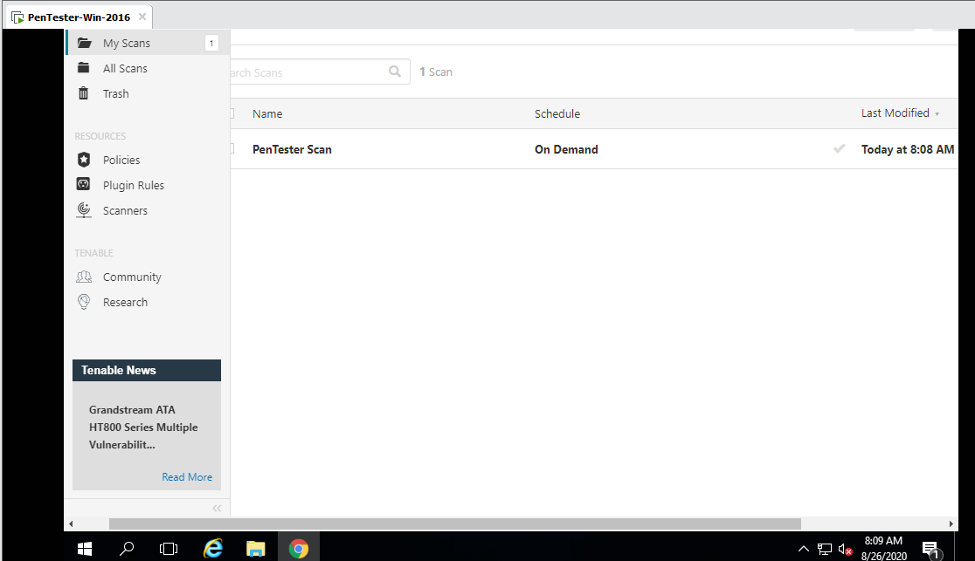

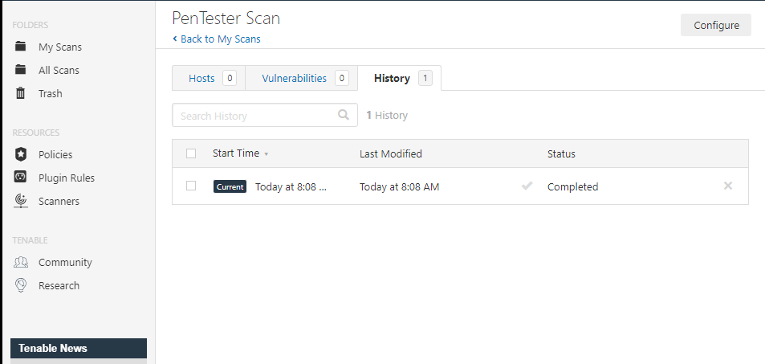

**THANK YOU**